INSTRUCTIONS FOR REPLACING GR390-12 RECEIVER BOARD

Read the following instructions thoroughly before using the remote.
This transmitter must be adjusted so that the coding switches match the coding on your present operating transmitters or receiver
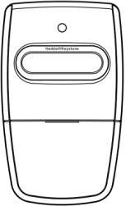
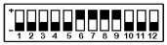
FCC Regulations: This device complies with FCC Rules Part 15. Operation is subject to following two conditions: 1) this device may not cause harmful interference. 2) This device must accept an interference that may cause an undesired operation. Transmitter distance may vary due to circumstance beyond our control.

Slider the cover for
battery replacement

Battery Type: 23A

Figure A

Figure B

Programming Remote Controller to the Opener

Remove the Transmitter Cover
Remove the access cover from the front of the transmitter by sliding the cover away from the top of the transmitter (Figure A). This will expose the battery and the dip switches. The code can now be changed using a small screwdriver.

Setting the codes
You may set your transmitter to any code you desire, but be sure the code you set matches both your transmitter and receiver.
There are twelve (12) dip switches, each of which can be placed in two different positions (+,-). DO NOT set all switches in the same position, such as all +, all -, (Figure B). WARNING: No other adjustments should be made inside the transmitter.

Terminal block for 9 dip switches receiver
For some receivers which only have 9 dip Switches, it will be necessary for you to move the small black code terminal (Open the housing with cross-shaped screwdriver (Figure C) to find terminal block (Figure D) ) to PINS in the middle and 9 .Therefore, the code selection of the 9 dip switches receiver model and the dip switches on your transmitter 1 thru 9 should be set exactly the same.
The same as those on your receiver, switches 10, 11,12 on the transmitter should be set in the off position.
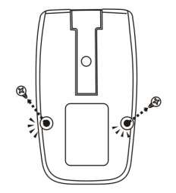
Open the housing with cross-shaped screwdriver Figure C
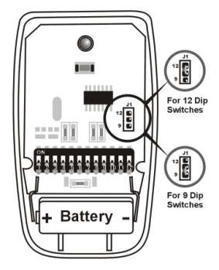

For 9 dip switches receiver, you have to move the small black code terminal to PINS in the middle and 9.
Figure D

Warning
To avoid possible serious injury or death from a garage door or moving gate:
-Keep all remote controls out of children’s reach at all times. Never allow children near batteries! -Only activate door or gate when it is in clear view and is in proper working condition.
-Always completely monitor garage door and gate opener until completely opened or closed.
-Never allow anyone to cross area of opening and closing of moving garage door or gate.
-Changes or modifications to this unit not expressly approved by the party responsible for compliance could void the user’s authority to operate this equipment.

Copyright@ KeystoneHeddolf Remotes 2015
ME-71-0001

