INSTRUCTION FOR RADIO CONTROL OPERATOR SINGLE ENTRY TRANSMITTER MODEL EX220-1K
Read the following instructions thoroughly before using the transmitter. This transmitter must be adjusted so that the coding switches match the coding switches on your receiver.
INSTRUCTION FOR SINGLE ENTRY TRANSMITTER
Remove the Transmitter Cover for battery replacement and set the Coding Switches
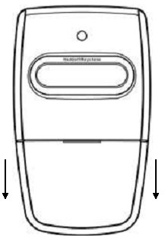
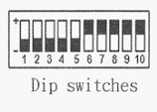
Figure A

1. Remove the transmitter cover
Remove the access cover from the front of the transmitter by sliding the cover away from the top of the transmitter. This will expose the battery and the dip switches. The code can be changed using a small screwdriver.
2. Setting the code
You may set your transmitter to any code you desire, but be sure that the code you set matches oh both your transmitter and receiver. There are 10 dip switches on your transmitter, each of which can be placed in two different position (on, off). Do not set all switches in same position, such as all ON or all OFF.
WARNING:
No other adjustment should be made inside the transmitter. Now that you have selected your personal code, replace the transmitter cover.
WARNING! Changes or modifications to this unit not expressly approved by the party responsible for compliance could void the user’s authority to operate this equipment.
Keystone Heddolf @2015

