INSTRUCTION FOR RADIO CONTROL TRANSMITTER MODEL GRC390-1K
Read the following instructions thoroughly before using the transmitter
The GRC390-1Kremote control works only with door openers that have an orange “learn button.
- Press and release the “learn” button on the motor unit. The learn indicator light will glow steadily for 30 seconds.
- Within 30 seconds, press and hold the button on the hand-held remote.
- Release the button when the motor unit light blinks. It has learned the code. If light bulbs are not installed, two clicks will be heard.
Replace the battery when the remote indicator light is dimer than normal.
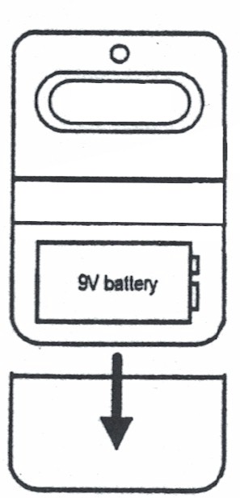
To replace the battery, slide the bottom cover down. Disconnect the battery from the battery connector carefully so as not to damage it then install the new 9-volt battery. Test to verify that the battery has been connected and the remote is working before replacing the cover.
NOTICE: To comply with FCC and or Industry Canada rules (IC), adjustment or modifications of this transmitter are prohibited, except for changing the signal learned or replacing the battery.
THERE ARE NO OTHER SERVICABLE PARTS.
Tested to comply with FCC Standards FOR HOME OR OFFICE USE. Operation is subject to the following two conditions: (1) this device may not cause
any harmful interference, and (2) this device must accept any interference received, including interference that may cause undesirable operation.

