INSTRUCTIONS FOR MINI REMOTE 219 MODELS
Read the following instructions thoroughly before using the remote.
This transmitter must be adjusted so that the coding switches match the coding on your present transmitters or receiver
FCC Regulations: This device complies with FCC Rules Part 15.
Operation is subject to the following two conditions: 1) This device may not cause harmful interference. 2) This device must accept an interference that may cause undesired operation. Transmitter distance may vary due to circumstances beyond our control.
Programming Remote Controller to the Opener
Remove the Transmitter Cover for battery replacement and set the Coding Switches
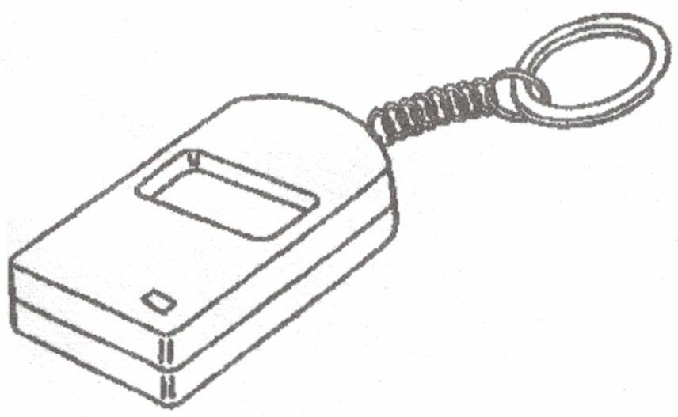
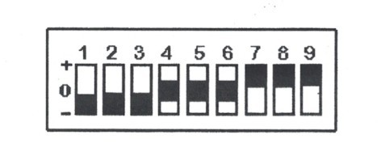
Figure A

- Remove the transmitter cover
Remove the screw from the back of the transmitter with a small Philips screwdriver. Lay the transmitter circuit board with the button facing up. Unsnap the top of the transmitter to access the coding switches.
- Setting the codes
You may set your transmitter to any code you desire, but be sure that the code you set matches both on your transmitter and receiver.
There are (9) dip switches, each of which can be placed in three different positions (+, 0, -). DO NOT set all switches in the same positions such as all +, all -, or all zero (Figure A). WARNING: no other adjustments should be made inside the transmitter
- To replace the Battery
If the red light on the transmitter is dim when the transmitter button is pushed, the transmitter battery may be weak. Remove the screw from the back of the transmitter with a small Philips screwdriver. Replace battery with a 32A 12-volt battery.
Warning
To avoid possible serious injury or death from garage door or moving gate:
-Keep all remotes out of children’s reach at all times. Never allow children near batteries!
-Only activate door or gate when it is in clear view and is in proper working condition.
-Always completely monitor garage door or gate opener until completely opened or closed.
-Never allow anyone to cross the opening or closing of moving garage door or gate.
-Changes or modifications to this unit not expressly approved by the party responsible for compliance could void the user’s authority to operate this equipment.

INSTRUCTIONS FOR MINI REMOTE 219 MODELS
Read the following instructions thoroughly before using the remote.
This transmitter must be adjusted so that the coding switches match the coding on your present transmitters or receiver
FCC Regulations: This device complies with FCC Rules Part 15.
Operation is subject to the following two conditions: 1) This device may not cause harmful interference. 2) This device must accept an interference that may cause undesired operation. Transmitter distance may vary due to circumstances beyond our control.
Programming Remote Controller to the Opener
Remove the Transmitter Cover for battery replacement and set the Coding Switches
Figure A

- Remove the transmitter cover
Remove the screw from the back of the transmitter with a small Philips screwdriver. Lay the transmitter circuit board with the button facing up. Unsnap the top of the transmitter to access the coding switches.
- Setting the codes
You may set your transmitter to any code you desire, but be sure that the code you set matches both on your transmitter and receiver.
There are (9) dip switches, each of which can be placed in three different positions (+, 0, -). DO NOT set all switches in the same positions such as all +, all -, or all zero (Figure A). WARNING: no other adjustments should be made inside the transmitter
- To replace the Battery
If the red light on the transmitter is dim when the transmitter button is pushed, the transmitter battery may be weak. Remove the screw from the back of the transmitter with a small Philips screwdriver. Replace battery with a 32A 12-volt battery.
Warning
To avoid possible serious injury or death from garage door or moving gate:
-Keep all remotes out of children’s reach at all times. Never allow children near batteries!
-Only activate door or gate when it is in clear view and is in proper working condition.
-Always completely monitor garage door or gate opener until completely opened or closed.
-Never allow anyone to cross the opening or closing of moving garage door or gate.
-Changes or modifications to this unit not expressly approved by the party responsible for compliance could void the user’s authority to operate this equipment.

INSTRUCTIONS FOR MINI REMOTE 219 MODELS
Read the following instructions thoroughly before using the remote.
This transmitter must be adjusted so that the coding switches match the coding on your present transmitters or receiver
FCC Regulations: This device complies with FCC Rules Part 15.
Operation is subject to the following two conditions: 1) This device may not cause harmful interference. 2) This device must accept an interference that may cause undesired operation. Transmitter distance may vary due to circumstances beyond our control.
Programming Remote Controller to the Opener
Remove the Transmitter Cover for battery replacement and set the Coding Switches
Figure A

- Remove the transmitter cover
Remove the screw from the back of the transmitter with a small Philips screwdriver. Lay the transmitter circuit board with the button facing up. Unsnap the top of the transmitter to access the coding switches.
- Setting the codes
You may set your transmitter to any code you desire, but be sure that the code you set matches both on your transmitter and receiver.
There are (9) dip switches, each of which can be placed in three different positions (+, 0, -). DO NOT set all switches in the same positions such as all +, all -, or all zero (Figure A). WARNING: no other adjustments should be made inside the transmitter
- To replace the Battery
If the red light on the transmitter is dim when the transmitter button is pushed, the transmitter battery may be weak. Remove the screw from the back of the transmitter with a small Philips screwdriver. Replace battery with a 32A 12-volt battery.
Warning
To avoid possible serious injury or death from garage door or moving gate:
-Keep all remotes out of children’s reach at all times. Never allow children near batteries!
-Only activate door or gate when it is in clear view and is in proper working condition.
-Always completely monitor garage door or gate opener until completely opened or closed.
-Never allow anyone to cross the opening or closing of moving garage door or gate.
-Changes or modifications to this unit not expressly approved by the party responsible for compliance could void the user’s authority to operate this equipment.

INSTRUCTIONS FOR MINI REMOTE 219 MODELS
Read the following instructions thoroughly before using the remote.
This transmitter must be adjusted so that the coding switches match the coding on your present transmitters or receiver
FCC Regulations: This device complies with FCC Rules Part 15.
Operation is subject to the following two conditions: 1) This device may not cause harmful interference. 2) This device must accept an interference that may cause undesired operation. Transmitter distance may vary due to circumstances beyond our control.
Programming Remote Controller to the Opener
Remove the Transmitter Cover for battery replacement and set the Coding Switches
Figure A

- Remove the transmitter cover
Remove the screw from the back of the transmitter with a small Philips screwdriver. Lay the transmitter circuit board with the button facing up. Unsnap the top of the transmitter to access the coding switches.
- Setting the codes
You may set your transmitter to any code you desire, but be sure that the code you set matches both on your transmitter and receiver.
There are (9) dip switches, each of which can be placed in three different positions (+, 0, -). DO NOT set all switches in the same positions such as all +, all -, or all zero (Figure A). WARNING: no other adjustments should be made inside the transmitter
- To replace the Battery
If the red light on the transmitter is dim when the transmitter button is pushed, the transmitter battery may be weak. Remove the screw from the back of the transmitter with a small Philips screwdriver. Replace battery with a 32A 12-volt battery.
Warning
To avoid possible serious injury or death from garage door or moving gate:
-Keep all remotes out of children’s reach at all times. Never allow children near batteries!
-Only activate door or gate when it is in clear view and is in proper working condition.
-Always completely monitor garage door or gate opener until completely opened or closed.
-Never allow anyone to cross the opening or closing of moving garage door or gate.
-Changes or modifications to this unit not expressly approved by the party responsible for compliance could void the user’s authority to operate this equipment.

