INSTRUCTIONS FOR Radio Control Operator
Dual entry transmitter P220-2KB Model
Triple entry P220-3KB Model
Read the following instructions thoroughly before using the remote.
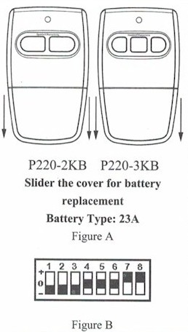
This transmitter must be adjusted so that the coding switches match the coding on your present transmitters or receiver

FCC Regulations: This device complies with FCC Rules Part 15.
Operation is subject to the following two conditions: 1) This device may not cause harmful interference. 2) This device must accept an interference that may cause undesired operation. Transmitter distance may vary due to circumstances beyond our control.

Programming Remote Controller to the Opener
- Remove the transmitter cover
Remove the access cover from the front of the transmitter by sliding the cover away from the top of the transmitter (Figure A). This will expose the battery and the dip switches. The code can now be changed using a small screwdriver.
- Setting the codes
You may set your transmitter to any code you desire, but be sure that the code you set matches both your transmitter and receiver.
There are (8) dip switches, each of which can be placed in three different positions (+, 0, -). DO NOT set all switches in the same positions such as all +, all -, or all zero (Figure A). WARNING: no other adjustments should be made inside the transmitter.

In the receiver, there are (9) dip switches. Set the first eight switches in the receiver so that they match exactly as the eight switch settings on the transmitter (Figure C). You will set the ninth dip switch to correspond with transmitter button that you wish to use to open the garage door. Each transmitter button corresponds to a (+, 0, -) setting. On the Dual Transmitter, the left button has a (+) setting and the right button has a setting of (0), On the Triple Transmitter, the left button has a (+) setting, the middle button has a setting of (0), and the right button has a setting of (-). Set the ninth switch in the receiver to the same setting (+, 0, -) as the button you wish to use. For example, if you wish to use the right button on the Dual Transmitter to open your garage, you should set the ninth dip switch on the receiver to (0).
Be sure not to use the same transmitter button that you selected to activate the gate opener. For example, on the Dual Transmitter, if you set the left button to open your gate, you would use the right button to open your garage door.
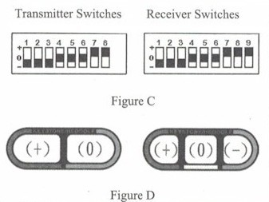

Warning
To avoid possible serious injury or death from garage door or moving gate:
-Keep all remotes out of children’s reach at all times. Never allow children near batteries!
-Only activate door or gate when it is in clear view and is in proper working condition.
-Always completely monitor garage door or gate opener until completely opened or closed.
-Never allow anyone to cross the opening or closing of moving garage door or gate.
-Changes or modifications to this unit not expressly approved by the party responsible for compliance could void the user’s authority to operate this equipment.

