KEYSTONE HEDDOLF INTERNATIONAL
RF Keypad Transmitter
TO PROGRAM THE KEYPAD:
- Open the keypad to install 4 AA batteries and to change the Dip Switches
- You will see (9) nine Dip switches each has 3-position setting (+, 0, -) P330-1KB 318MHz
- Set the Dip switches to match that of your receiver, gate or garage door opener.
- To change the master code: [users’ choice-not necessary on most applications]
- Enter the default code: 1 2 3 4
- Press the programming button *- (green led on)
- Enter 1
- Enter 0 0
- Enter your new 4 digits MASTER code (green led flashes twice/Off)
- Press programming button
- PROGRAM THE USER COPDE (Up to 60 different User codes)
3-a. Enter the Master code.
3-b. Press the programming button *- (green led on)
3-c. Enter 1
3-d. Enter 0 1 then your first 4 digits User code
3-e. Press programming button * (green led flash twice/Off)
You are now complete with the first User code.
If you wish to install more User codes simply
REPEAT STEPS 3-d and 3-e
- Enter 0 2, your second 4 digits User code, then programming button*
- Enter 1 0, your tenth 4 digits User code, then programming button * or
- Enter 5 0, your fiftieth 4 digits User code, then programming button* ect.
3-f. If you do nothing for three seconds, Keypad will leave programming status.
- DELETING A PROGRAM USER CODE
4-a. Enter your master code
4-b. Press the programming button*
4-c Enter 2
4-d Enter the 2 digits code you want to delete
i.e, 0 3 for the third user code or 5 0 for fiftieth user code
4-e. Press the programming button * (green led flash twice/Off
If you wish to install more User codes simply
REPEAT STEPS 4-d and 4-e
- Enter 0 2, your second User code, then programming button* or
- Enter 1 0, your tenth User code, then programming button * or
- Enter 5 0, your fiftieth User code, then programming button* etc.
4-f. If you do nothing for three seconds, Keypad will leave programming status.

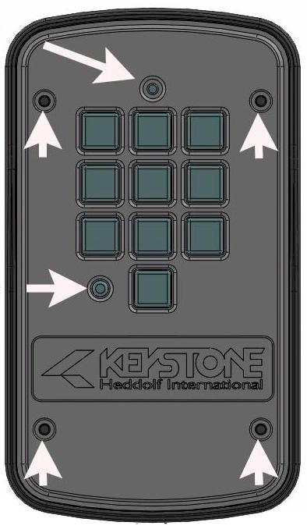
Multi-color status LED

Programming button

4 screws for battery replacement

5. RETURN TO DEFAULT SETTINGS.
5-a. Disconnect all batteries- TAKE ALL POWER AWAY
5-b. Depress 3, 6, 9 AND put the power back to the keypad at same time.
MULTI COLOR STATUS LED will display ORANGE Color and Flashing from quick turn to slow then off
5-c. When all lights turn off, you can release the buttons.
The keypad is back to factory settings with NO programmed codes.

WIREING DIAGRAM
1. Disconnect the RF transmitter by moving the jumper (TX Time) to J0 for HARD WIRE ONLY.
2. Connect the accessories (e.g., electronic door lock & 12 or 24V power supply) to terminal block.
3. Adjusting RF transmitter – Maybe necessary for some openers.
Moving the jumper (TX Time) to
- J0 transmit to 0 seconds
- J1 transmit to 1 second
- J2 transmit to 2 seconds
- J3 transmit to 3 seconds
- J4 transmit to 4 seconds

NOTE: Only remove rubber peg on back of
Keypad housing if hardwiring
Wires will fit snug through hole

ATTENTION: Coiled wire antenna in housing – if needed pull end of antenna wire thru the rubber pegged opening that is used for hardwiring applications
Copyright © 2019 Keystone/Heddolf International. All rights reserved.

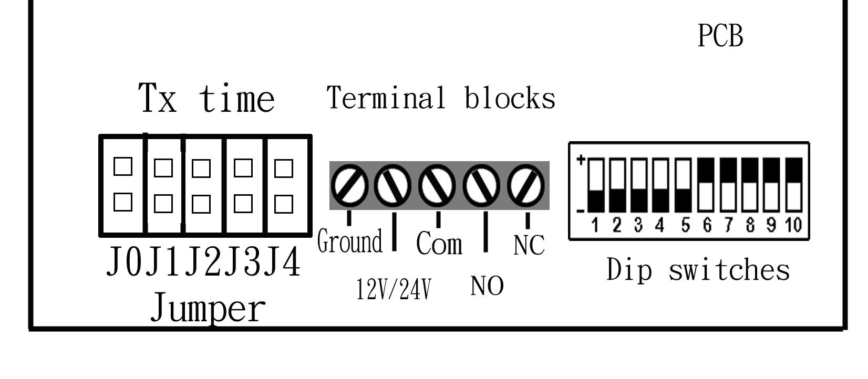
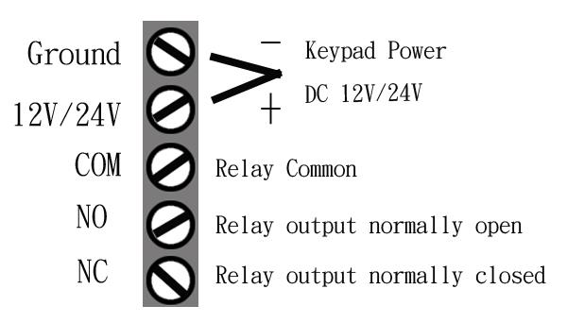
MULTI COLOR STATUES LED
ORANGE- When any keys are pressed
GREEN STEADY - Program mode
GREEN FLASHING 2 times then STEADY - Program or Delete one user code completed
GREEN FLASHING 3 times – Error during program mode
RED – Entered the correct code and transmitting

